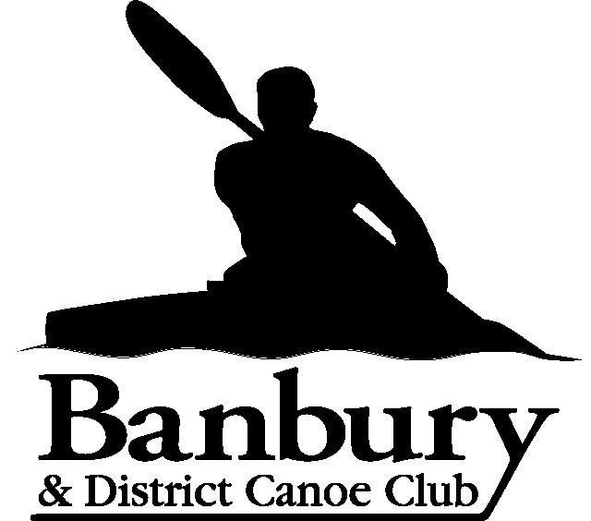
Ross Warland Memorial
Canal Challenge
Sunday 28th November 2021
The race is held in memory of Ross Warland and other young people who did not have the opportunity to reach their full potential in life. Ross, who died of bone cancer in February 2000 at the age of 21, was an active and popular member who first joined the club when he was 8 years old. When no longer able to paddle he devoted his time to coaching and training the club members. His attitude and courage towards his illness was an inspiration to all those that met him.
In the interests of public safety there will be no running the Banbury Lock portage. However a gentle, controlled jog will be permitted. This will be enforced and the offenders disqualified by the marshals who will be present.

Classes
- K1/C1 full distance (20 miles)
- K2/C2 full distance (20 miles)
- K1/C1 relay teams No more than 2 paddlers per team
- K2/C2 relay teams Two pairs per team
- Note: paddlers under 16 years of age may compete only as part of relay teams.

Race Details
Distance: 20 miles, 12 portages.

Entries.
Entries will be online using the MRC race entry system and payment will be via either BAC’s or cheque.
BAC’s payment to Banbury & District Canoe Club. Sort Code 08-92-99. Account number 65552496
Please use the following reference: Ross Warland 2021/competitor name.
Cheques payable to Banbury & District Canoe Club and to be sent for the attention of Graham Warland, 9 Woodhall Drive, Banbury, OX16 9TY.
Any issues with using the entry system then please contact Graham Warland graham.warland@gmail.com
Late entries will be allowed and we will accept cash for these but would prefer BAC’s payment.
Please provide a contact phone number and/or email in case of late cancellation. If not please monitor the club website www.banburycanoeclub.com

Timetable
Booking in from 8 am. The first start time will be at 9-15am, for novice, unranked and divisions 7-9 and 10-00am for divisions 1-6. Paddlers will be set off at regular intervals thereafter, with the last start time being 11am.
The finish will close at 2.30 pm so paddlers will need to base their start time on their calculated paddling speed. For those paddlers who expect to record slower times, please ensure that you are on the start line early in order to have your finish time recorded.

- Start: Banbury Canoe Club, Cropredy Wharf, Cropredy OX17 1PG. O/S map 151 ref. (468, 465).
Four miles north of Banbury. Follow A423 Southam Road from Banbury. Signpost pointing right to Great Bourton and Cropredy.
- Turn point: Nell Bridge, Aynho Lock at 10 miles. O/S map 151 Explorer ref (484, 342)
- Finish: Banbury Canoe Club, Cropredy Wharf, Cropredy, OX17 1PG

Changeovers.
There is the possibility of 2 designated changeover points depending on the distance a relay team wishes to paddle at in one go i.e. 4.5 miles or 10 miles.
- Banbury Lock near the Spiceball Sports Centre & Castle Quay Shopping Centre at 4.5 miles from Cropredy. O/S map 191 Explorer ref (458, 408).
- Nell Bridge at Aynho Lock at 10 miles. O/S map 151 Explorer ref (484, 342).

Rules
- As per the Racing Yearbook 2021. All division 7, 8 and 9 paddlers must wear approved buoyancy aids. Team Leaders to decide on juniors outside these divisions.
- Banbury Lock portage situated in Castle Quay Shopping Centre. In the interests of public safety there will be no running this portage. Marshals will be on hand to observe and, if necessary, penalise those paddlers that are irresponsible. However, in order not to impinge on the race itself we will allow a jog on the portage but no sprinting or irresponsible running please as the portage cuts across a footpath used by shoppers including children.
- How teams use the changeovers is down to them. Please note that you must swop numbers and they must be visible.
- Each team may need a support team to transfer their boats between stages.
- Competitors and team leaders should note that competitors participate at their own risk, and that Banbury and District Canoe Club cannot be held responsible for any loss or injury to person or property however caused.
Suitable footwear is advisable and the organisers will reserve the right to refuse access to the water to paddlers that they deem are not wearing sufficient clothing for the conditions of the day.
- All paddlers may be required to wear buoyancy aids if the organiser deems it necessary due to the prevailing conditions.
- Junior teams must have a support crew in attendance.

Fees
Adults: £10.00 per seat. Juniors: £8.00 per seat.
Event tickets at £5.00 per seat as per the British Canoeing ruling. Note the club does not retain any of the monies from day tickets.

Refreshments
Entry fee includes refreshments (bacon rolls, veggie rolls & soup plus hot & cold drinks). They are also free to support crews and spectators. However please feel free to donate to the Bone Cancer Trust who provide such a tremendous support service, not only for children suffering from cancer, but also their families.

Parking
Please do not park in the vicinity of the canal bridge or cause any obstruction to residents in the village.
Please park in the Sports Club car park which is situated on the left hand side of the road prior to entering the village from Williamscott via the A361 or, if it is full, please park responsibly in the village itself, taking care not to cause an obstruction with passing traffic or causing issues with the local residents. Please remember - we will be here next week and hopefully for years to come, and we do not want to suffer the wrath of the local residents and authorities.

Changing facilities
Changing facilities including hot showers and toilets will be available at the Sports Club in addition to toilets at the canoe club.

Towpath
For those that are either cycling or running the route in support of their crews, please note that in parts there are potholes and bank erosion in some sections of the towpath that cannot be seen easily due to leaves etc.

Portages
Note that with the exception of Banbury Lock all portages are on the left-hand side on the downward stretch.

GDPR
Use of entry data is classed as “reasonable use”, and by entering a race a paddler may be considered to have given consent for the data submitted to be used for the calculation and publication of results and rankings. Banbury & District Canoe Club will not be seeking further consent for using the data in the prescribed way. Team leaders submitting entries for their club(s) should have individual consents in
accordance with BC's guidance & Tool Kit on GDPR. The Race Result data showing Name, Club, Finish Time, Placing and Division may be published and held on BDCC’s website. Paddlers may request deletion of their historical data by contacting the race organiser in accordance with BC's data protection policies.

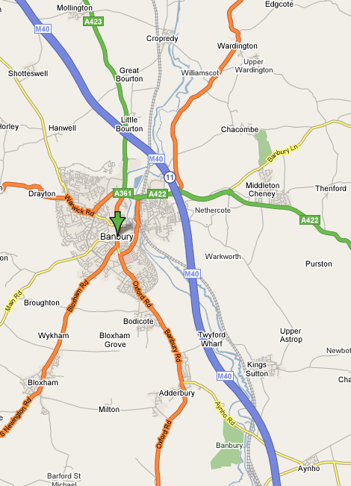
Start and finish.
Turn.

