
Ross Warland Memorial
Canal Challenge
Sunday 24th November 2024
The race is held in memory of Ross Warland and other young people who did not have the opportunity to reach their full potential in life. Ross, who died of bone cancer in February 2000 at the age of 21, was an active and popular member who first joined the club when he was 8 years old. When no longer able to paddle he devoted his time to coaching and training the club members. His attitude and courage towards his illness was an inspiration to all those that met him.
- In the interests of public safety there will be no running the Banbury Lock portage. However, a gentle, controlled jog will be permitted. This will be enforced, and the offenders disqualified by the marshals who will be present.

Classes
- K1/C1 full distance (20 miles)
- K2/C2 full distance (20 miles)
- K1/C1 relay teams - no more than 2 paddlers per team
- K2/C2 relay teams - two pairs per team
- Note 1: paddlers under 16 years of age may compete only as part of relay teams.
- Note 2: any paddler under 16 years of age wishing to race K1 all the way through should contact the race organiser detailing their ranking, age, experience, club, coach, and support crew. The race organiser then make a decision based on the details provided.

Race Details
Distance: 20 miles, 12 portages.

Entries.
Entries will be online using the MRC race entry system and payment will be via Stripe.
Any issues with using the entry system then please contact Graham Warland graham.warland@gmail.com
Late entries will be allowed on the day.
Please provide a contact phone number and/or email in case of late cancellation. If not, please monitor the club website www.banburycanoeclub.com

Timetable
- Booking in from 8 am.
- The first start time will be at 9-00am, for novice, unranked.
- 9-15 for divisions 7-9.
- 9-45 for divisions 4-6.
- 10-00 for divisions 1-3.
Paddlers will be set off at regular intervals thereafter, with the last start time being 11am.
The finish will close at 2.00 pm so paddlers will need to base their start time on their calculated paddling speed. For those paddlers who expect to record slower times, please ensure that you are on the start line early in order to have your finish time recorded.

- Start: Banbury Canoe Club, Cropredy Wharf, Cropredy OX17 1PG. O/S map 151 ref. (468, 465).
Four miles north of Banbury. Follow A423 Southam Road from Banbury. Signpost pointing right to Great Bourton and Cropredy.
- Turn point: Nell Bridge, Aynho Lock at 10 miles. O/S map 151 Explorer ref (484, 342)
- Finish: Banbury Canoe Club, Cropredy Wharf, Cropredy, OX17 1PG

Changeovers.
There is the possibility of 2 designated changeover points depending on the distance a relay team wishes to paddle at in one go i.e. 4.5 miles or 10 miles.
- Banbury Lock near the Spiceball Sports Centre & Castle Quay Shopping Centre at 4.5 miles from Cropredy. O/S map 191 Explorer ref (458, 408).
- Nell Bridge at Aynho Lock at 10 miles. O/S map 151 Explorer ref (484, 342).

Rules
- As per the Marathon Racing Yearbook 2024. All division 7, 8 and 9 paddlers must wear approved buoyancy aids. Team Leaders to decide on juniors outside these divisions.
- Banbury Lock portage situated in Castle Quay Shopping Centre. In the interests of public safety there will be no running this portage. Marshals will be on hand to observe and, if necessary, penalise those paddlers that are irresponsible. However, in order not to impinge on the race itself we will allow a jog on the portage but no sprinting or irresponsible running please as the portage cuts across a footpath used by shoppers including children.
- How teams use the changeovers is down to them. Please note that you must swop numbers and they must be visible.
- Each team may need a support team to transfer their boats between stages.
- Competitors and team leaders should note that competitors participate at their own risk, and that Banbury and District Canoe Club cannot be held responsible for any loss or injury to person or property however caused.
Suitable footwear is advisable and the organisers will reserve the right to refuse access to the water to paddlers that they deem are not wearing sufficient clothing for the conditions of the day.
- All paddlers may be required to wear buoyancy aids if the organiser deems it necessary due to the prevailing conditions.
- Junior teams must have a support crew in attendance.

Fees
Adults: £12.00 per seat. Juniors: £10.00 per seat.
Event/Day tickets £5.00 for those not a member of British Canoeing or an affiliated club, as required by British Canoeing for insurance purposes. Note the club does not retain any of the monies from day tickets.

Refreshments
Entry fee includes refreshments (bacon rolls, veggie rolls & soup plus hot & cold drinks). They are also free to support crews and spectators. However please feel free to donate to the Bone Cancer Trust who provide such a tremendous support service, not only for children suffering from cancer, but also their families.

Parking
Please do not park in the vicinity of the canal bridge or cause any obstruction to residents in the village.
Please park in the Sports Club car park which is situated on the left hand side of the road prior to entering the village from Williamscott via the A361 or, if it is full, please park responsibly in the village itself, taking care not to cause an obstruction with passing traffic or causing issues with the local residents. Please remember - we will be here next week and hopefully for years to come, and we do not want to suffer the wrath of the local residents and authorities.

Changing facilities
Changing facilities including hot showers and toilets will be available at the Sports Club in addition to toilets at the canoe club.

Towpath
For those that are either cycling or running the route in support of their crews, please note that in parts there are potholes and bank erosion in some sections of the towpath that cannot be seen easily due to leaves etc.

Portages
Note that with the exception of Banbury Lock all portages are on the left-hand side on the downward stretch.

Safety
Emergency phone number

Banbury & District Canoe Club 01295 710758844.

Defibrillator:

There are defibrillators located at the Castle Quay Shopping Centre at Banbury Lock. On the outside wall of Castle Quay centre near Wild Lime (old Marks and Spencer exit)

Banbury Business Park 800 yards from Nell Bridge on the road to Adderbury.

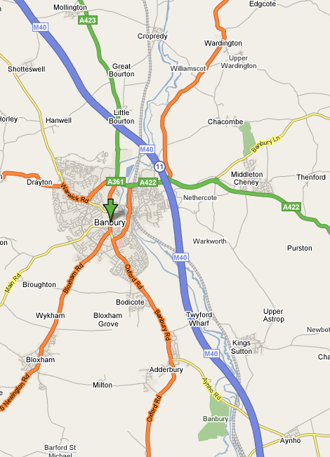
Start and finish.
Turn.

