Ross Warland Memorial Canal Challenge – course description

This document describes the course used for the Banbury Canoe Club, Ross Warland Memorial Canoe Challenge. It is a simple aide-memoir for anyone who has not done this event before, and is not familiar with the course.

Hosts: Banbury Canoe Club
Contact: Graham Warland. graham.warland@gmail.com
Date: 30th November 2025

Host web site: http://banburycanoeclub.com/

Parking
Parking at a nearby sports club.

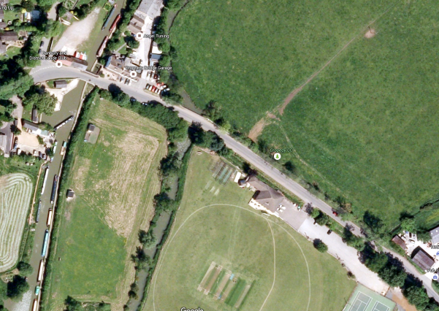
Car park
Banbury Canoe Club
52.114419 N
-1.314403 (W)

The Course
The course is a twenty mile there-and-back route along the Oxford Canal, with twelve portages. It’s all canal but even though it’s flat water, it can become a bit bumpy from the refracted waves from the vertical sides.

Portages
All the get outs and put ins are straight forward and an easy step-in/out. Crews may find the gap between the ends of the lock gate arms and the hedge a bit narrow. Probably best to shoulder the boat. Some of the paths down to the canal are a bit tight as the route goes under the bridge.

Out leg:

- Slat Mill lock (1 and 12) – 1.8 kms (1.16 miles)
- Little Bourton lock (2 and 11) – 1.4 km (0.9 miles)
- Hardwick lock (3 and 10) – 1.3 km (0.8 miles)
- Banbury lock (4 and 9) – 2.7 km (1.7 miles)
- Grants lock (5 and 8) – 3.4 kms (2.1 miles)
- Kings Sutton lock (6 and 7) – 2.25 kms (1.4 miles)
- Turn – 3kms (1.9 miles)

It starts at the Banbury Canoe Club just downstream of Cropredy Lock.

Proceed south, downstream towards Banbury. Follow the canal to the first portage at Slat Mill Lock after about 1.1 miles. Straight forward portage, get out on the left, traverse the lock, get in again.

The next portage after 0.9 miles is Little Bourton lock. It’s a left hand get out, and then pass in front of the building and you have to squeeze past the ends of the lock gate beams.

After a further 0.8 miles, portage Hardwick Lock. Get out on the left, traverse the lock, go under the bridge and put in just afterwards.

Next up is Banbury Lock after 1.7 miles. This is a right hand portage, and you are not allowed to run this, put in under the road bridge.

Following Banbury is Grants Lock, after about 2 miles. Get out on the left, traverse the lock, go under the bridge and put in just afterwards.

Continue downstream to the next portage at Kings Sutton Lock just after another 1.4 miles. Get out on the left, traverse the lock, go under the bridge and put in just afterwards.

Paddle on for another 1.8 miles to the turn at 10 miles. Turn (obviously!) and paddle back to the start doing the portages in the reverse order.

Course map – part 1

Course map – part 2

Turn
Grants Lock
5 and 8
Kings Sutton Lock
6 and 7
Banbury Lock
4 and 9

Slat Mill Lock
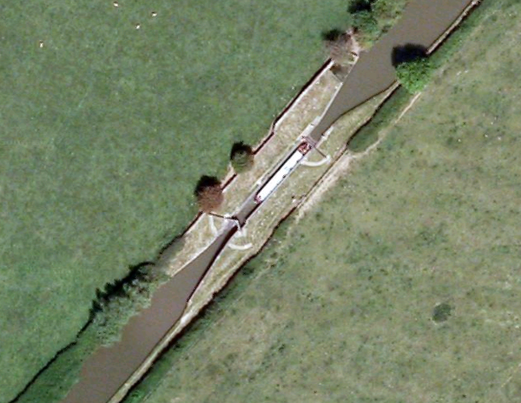

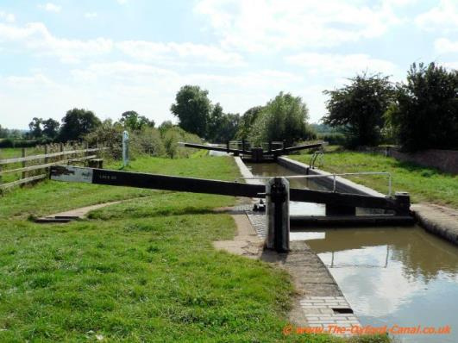 | 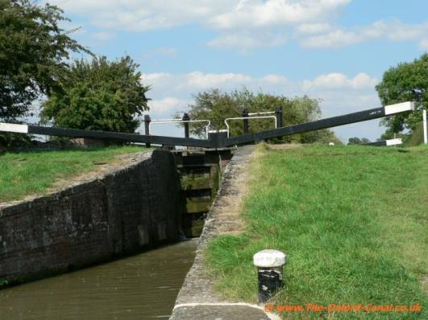

Little Bourton Lock
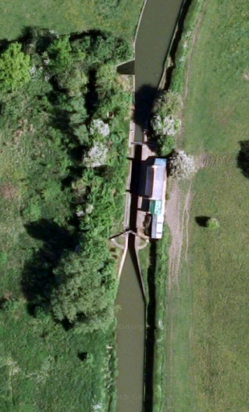

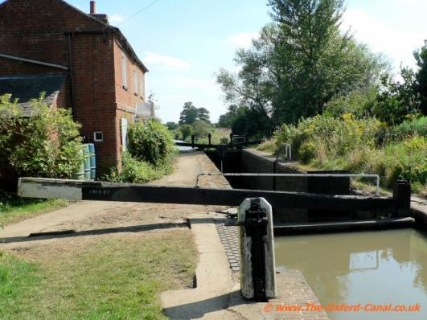 | 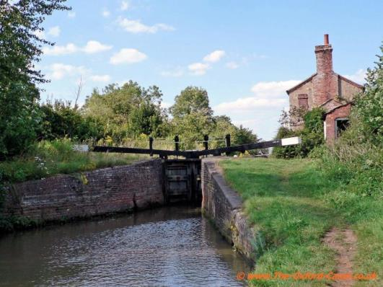

Hardwick Lock

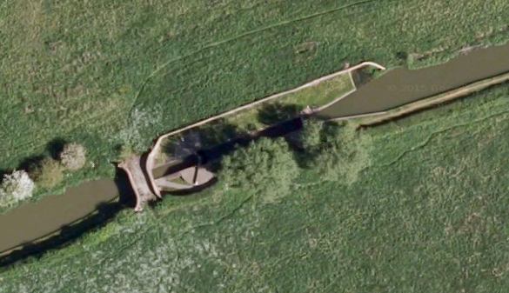

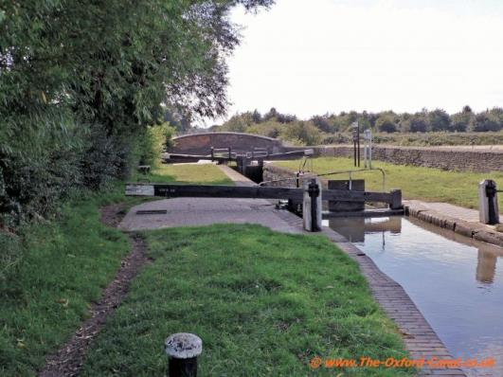 | 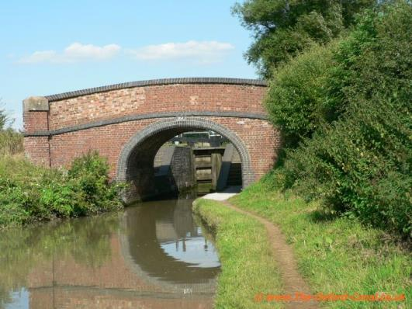

Banbury Lock

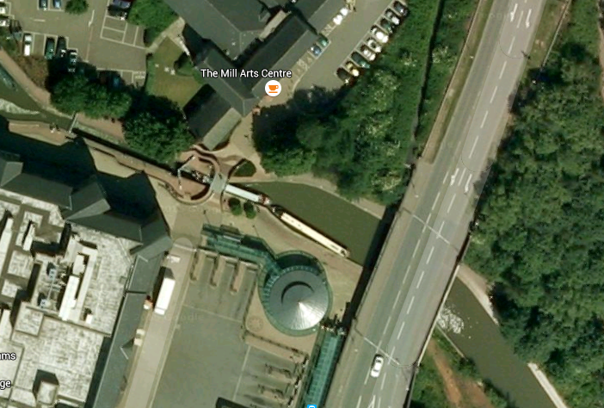
Banbury lock

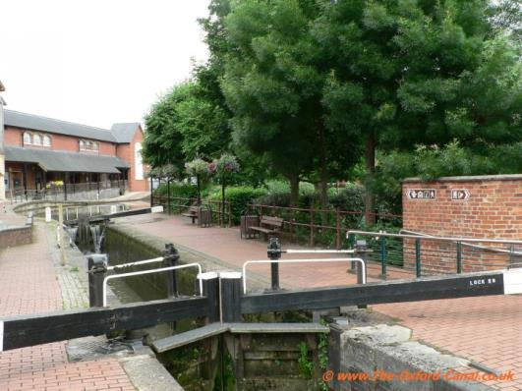 | 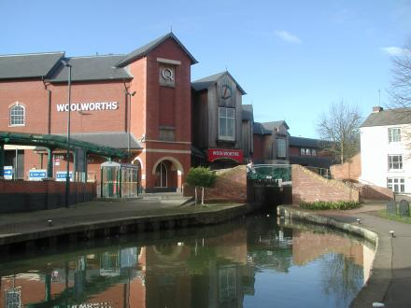

Grants lock

Kings Sutton Lock

The Turn
The turn is at the ten mile point after the swing bridge. There is a big area in which to turn.

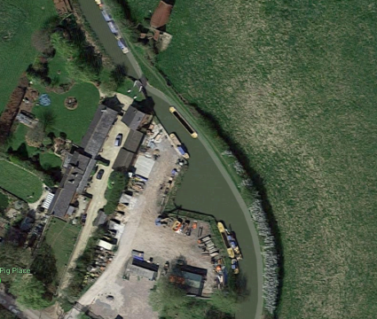

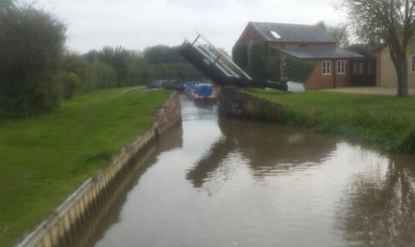 | 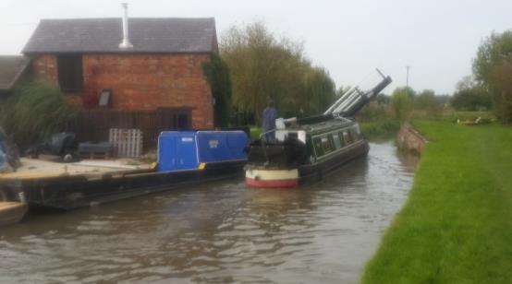

The Finish
The finish line is at the same place as the start.

end

