


South Lakes Marathon 1 - Lancaster Canal

NW Hasler Events

Sunday 13th September 2026

Organised by Duddon Canoe Club

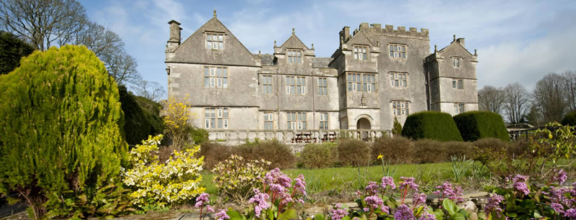
Venue: Borwick Hall, Lancaster Canal (self-catering accommodation available)

Classes: Singles Divisions 1 to 9
Doubles Divisions 2 to 9
Geoff Sanders U14 Div. A B C

Adult £10, U18 £5, GS £3.

Courses: Divisions Distance Portages

1, 2, 3 singles 19 kilometres 1
2/3 doubles

4, 5, 6 singles 13 kilometres 1
4, 5, 6 doubles

7, 8, 9 singles 6.5 kilometres 0
7, 8, 9 doubles

Geoff Sanders 2 kilometres 0

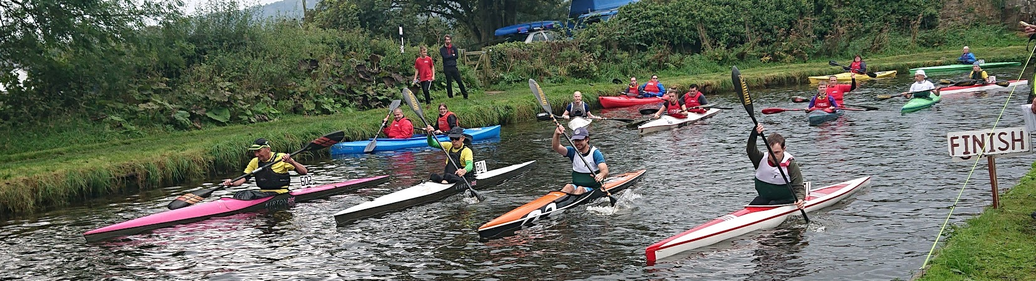

Contact johnsherwen@hotmail.com

