

South Lakes Marathon 1

Lancaster Canal

NW Hasler Event

Sunday 10th September 2023

Organised by Duddon Canoe Club

Venue: Borwick Hall, Lancaster Canal. The race will begin and end at Borwick Hall, Borwick, LA6 1JX, running in Laps between Carnforth and Tewitfield.

Classes: Singles Divisions 1 to 9
Doubles Divisions 2 to 9
Geoff Sanders A B C
Approved buoyancy aids must be worn by all division 7, 8, paddlers and Geoff sanders racers.

The wearing of buoyancy aids by under 16 year old paddlers in other divisions is strongly advised but is ultimately at the discretion of team captains.

Courses: Divisions Distance Portages

1, 2, 3 singles 21 kilometres 1
2/3 doubles

4, 5, 6 singles 13 kilometres 1
4, 5, 6 doubles

7, 8, 9 singles 6.5 kilometres 0
7, 8, 9 doubles

Geoff Sanders 2 kilometres 0

NB distances may vary slightly according to water conditions on the day.

Timetable: Check-in between 09.00 and 11.00

Briefing 11.10
Start of Lightning race 11.30
Start of Divisional races 12.30

Refreshments: Light refreshments will be available for competitors after the race.

Rules: BC Marathon Racing Committee rules will apply.

All paddlers must have valid BC / NGB membership.

Paddlers in divisions 1 to 6 who cannot show comprehensive membership will not be allowed to race.

Paddlers in divisions 7, 8 and 9 may buy an Event Ticket for a fee of £5,

All BC affiliated club members who are on their club BC portal will have a BC number.

Paddlers in doubles divisions must declare their singles ranking status at check-in or they will not qualify for Hasler points.

All paddlers are warned that there will be traffic in the area of the race and due care must be taken when racing.

Vertical number plates are compulsory for all except division 9
boats and the Geoff Sanders race.

Each boat must have sufficient buoyancy to remain afloat and support the paddler in the event of capsize.

Entries: Send entries via the HRM system or on the attached form together with the
correct entry fees (cheques payable to Duddon Canoe Club) to;
John Sherwen
5 Spring Vale,
Swarthmoor,
Ulverston.
LA12 0XA
johnsherwen@hotmail.com 01229 462905

Entry fees: £8 per seat senior
£5 per seat junior
£3 per seat Geoff Sanders
£5 Event Ticket
Late entries accepted until 10.00 am. On the day

Prizes: Prize giving will take place as soon as possible after the end of racing. There will be a prize for the winner of each quorate race plus others as appropriate.

Notes: No dogs are allowed on the Borwick Hall owned section of the Canal start and Finish area. There is a public footpath on the opposite (western) side of the canal, where spectators with dogs are welcome.
Due to other activities at the hall, parking may be limited, and people are encouraged to car share when possible.

DCC South Lakes Marathon
10th April 2023
Entry Form

Return to:- John Sherwen 5 Spring Vale, Swarthmoor, Ulverston, LA12 0XA . johnsherwen@hotmail.com

Name | Full BC number | Expiry Date | Status  J/S/L/V/C | Division  entered | Singles  Division if K2 | Entry Fee  enclosed

Name of club………………………………………………………………………

Name, address & phone number of team leader…

……………………………………………………………

…………………………………………

……………………………………
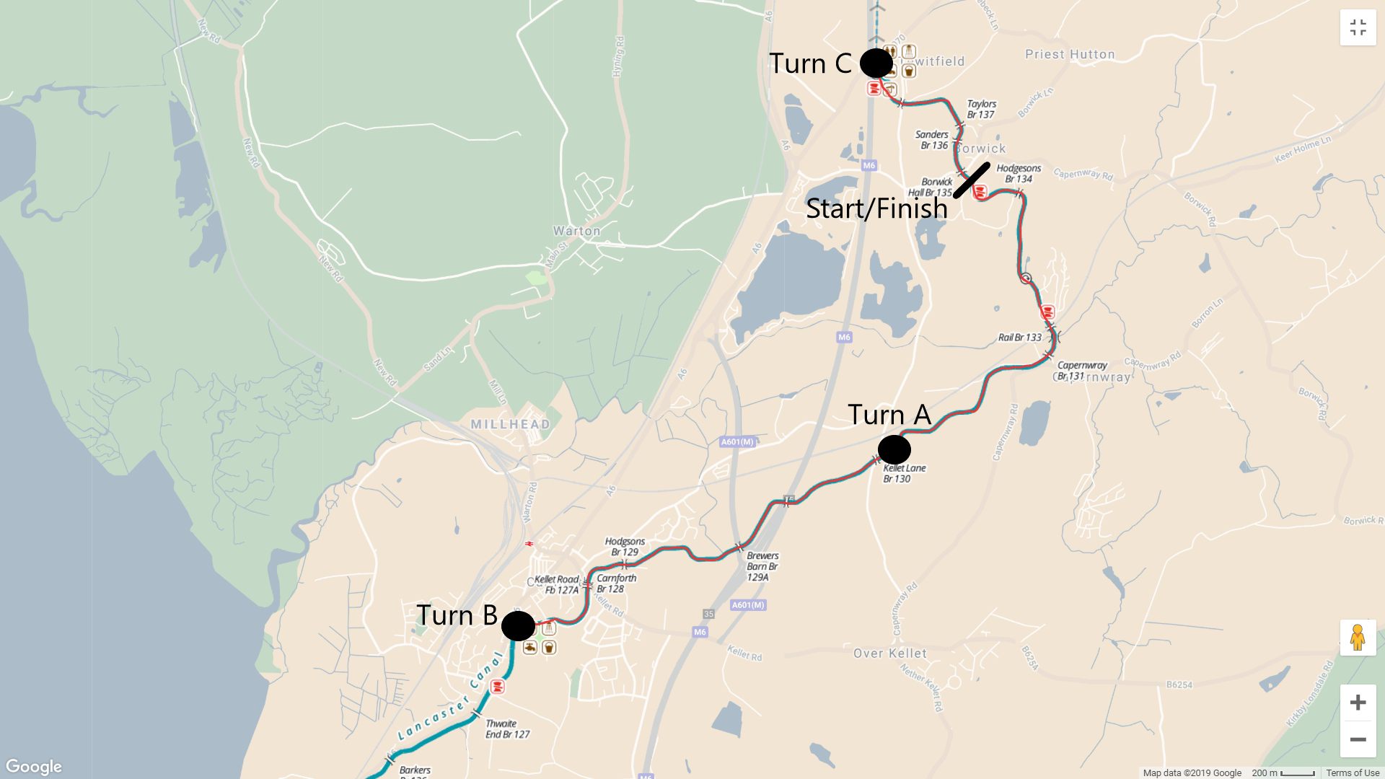

The race will be run as laps, within the boundaries of turn B and C.

6.5km Course - Start - Paddle to Turn A Paddle to Finish.
13km Course - Start – Paddle to Turn B, Paddle to Turn C, Paddle to Finish.
21km Course - Start – Paddle to Turn B, Paddle to Turn C, Paddle to Turn A, Paddle to Turn C Paddle to Finish.
Geoff Sands Course – Start – Paddle to turn buoy in Canal Spur 1km from start, Paddle to Finish.

Camping and Accommodation
Accommodation is available at Borwick Hall, and may be booked direct using +44 (0)1524 732 508

