
Selection races
Saturday 10 & Sunday 11 August 2024
Location: Falcon Boat Club, near Donnington Bridge, Oxford, OX4 4BJ
Car parking is at Falcon Boat Club, Meadow Lane. Car parking is limited:
- Please car share wherever possible
- Please do not park on Meadow Lane
- If the car park is full, please drop off your boat and then park at Redbridge Park and Ride (15 minutes walk away)
- Para athletes will have reserved car parking spaces in the car park, closest to the club
- Spectators are very welcome, but please use the Park & Ride car park if you are coming separately to athletes
Races
Saturday
- K2 senior and junior; men and women
- C2 senior and junior men
Sunday
- K1 and C1; men and women; senior, junior and U23
- K1 and Va’a; men and women; para classes 1-3

Course
The course will be composed of approx 4.5km laps, with the first lap slightly shorter than all subsequent laps. Races will start a few hundred metres upstream of Falcon where the river is widest and fairly straight. Starts will be upstream, turning anti-clockwise around Folly Island. You will then head downstream, past Falcon, turning anti-clockwise around a buoy a few hundred metres above Iffley lock. The portage will be at Falcon: both the get out and get in are on landing stages. The finish will be at Falcon. Maps will be available on the day.
- Senior men approx 25km: 6 laps, 5 portages
- Senior women approx 21km: 5 laps, 4 portages
- Junior men approx 21km: 5 laps, 4 portages
- Junior women approx 17km: 4 laps, 3 portages
- Senior men canoe approx 21km: 5 laps, 4 portages
- Senior women, junior men & junior women canoes approx 17km: 4 laps, 3 portages
- Paracanoe approx 8km: 2 laps, 0 portages
Timings (same for both days)
12:00 Check in opens
13:30 Briefing
14:10 Senior men kayak start
14:12 Junior men kayak start
14:14 Senior women kayak & senior men canoe start
14:16 Junior women kayak, senior women canoe, junior canoes start
14:18 Para canoe (all classes) start
Entry Fees
● Seniors: £20 per seat per race (late entry £25)
● Juniors: £15 per seat per race (late entry £20)

All entries and payment via the Race Entries system. Deadline 9pm Friday 9 August. Late entries will be accepted until 1pm on race day. Entrants must be members of Paddle UK. Any problems / changes to entries, please email jobatesfalcon@gmail.com.
Facilities
There are changing rooms with hot showers upstairs and a disabled changing room downstairs. There is a lift to the first floor. The club cafe will be open both days

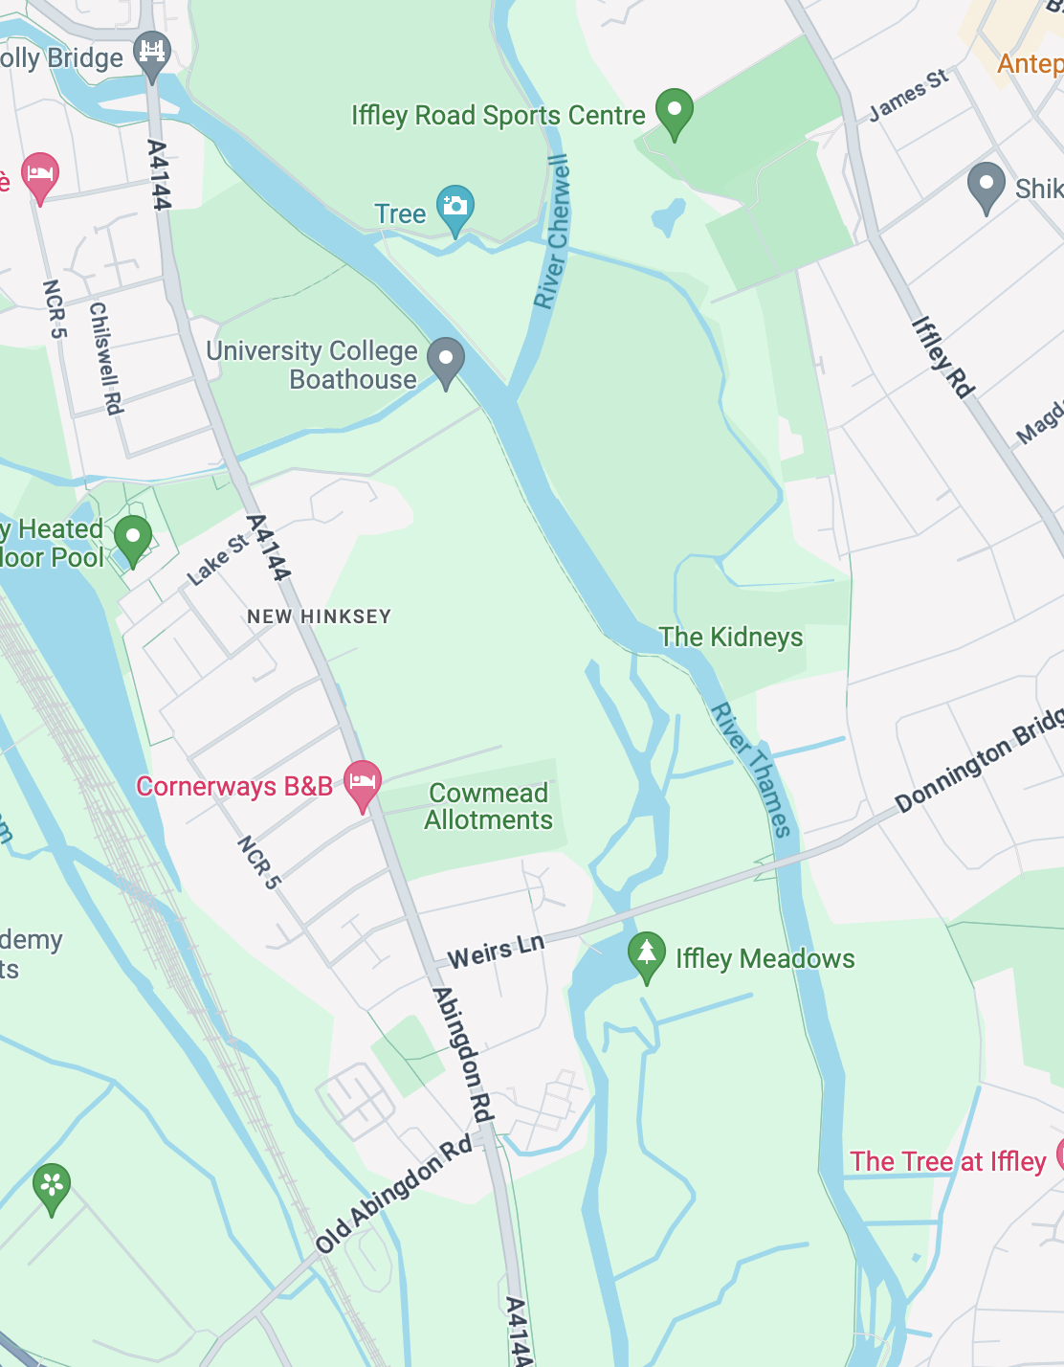
Turn around buoy,
Iffley lock
Turn around Folly island
Start
Club, finish & portage

