
Leighton Buzzard Canoe Club
Remembrance Day Marathon
Sunday 14th November 2021

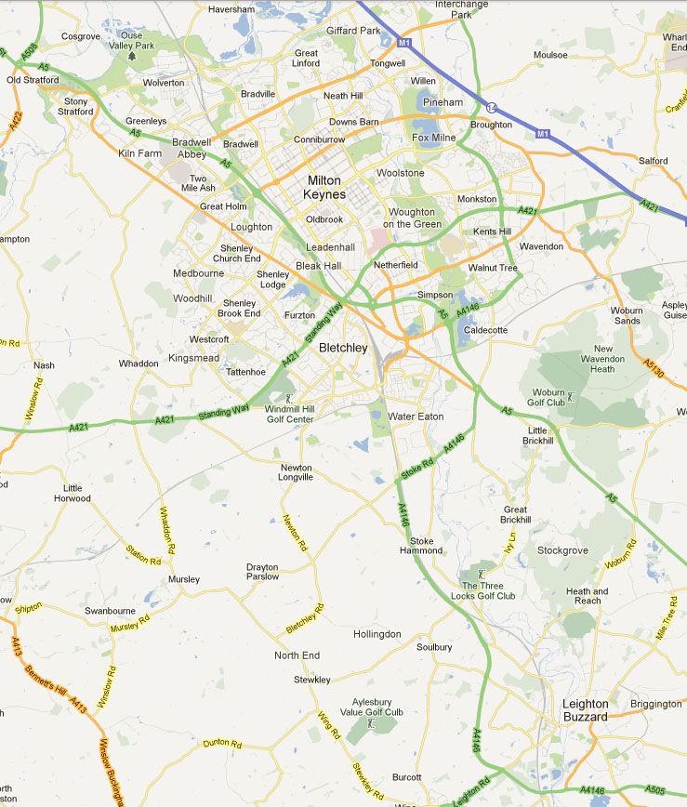
Fenny Lock
Leighton Lock
Stoke Hammond Lock
Start
Three Locks
Finish
Course Location Street Map

START LOCATION Great Linford Memorial Hall, Marsh Drive, Great Linford, Milton Keynes MK14 5AX, for Booking In, Car Parking, Toilets & Refreshments available

The start will be at Great Linford Wharf, on the Grand Union Canal, Marsh Drive, Milton Keynes, Bridge Number 77

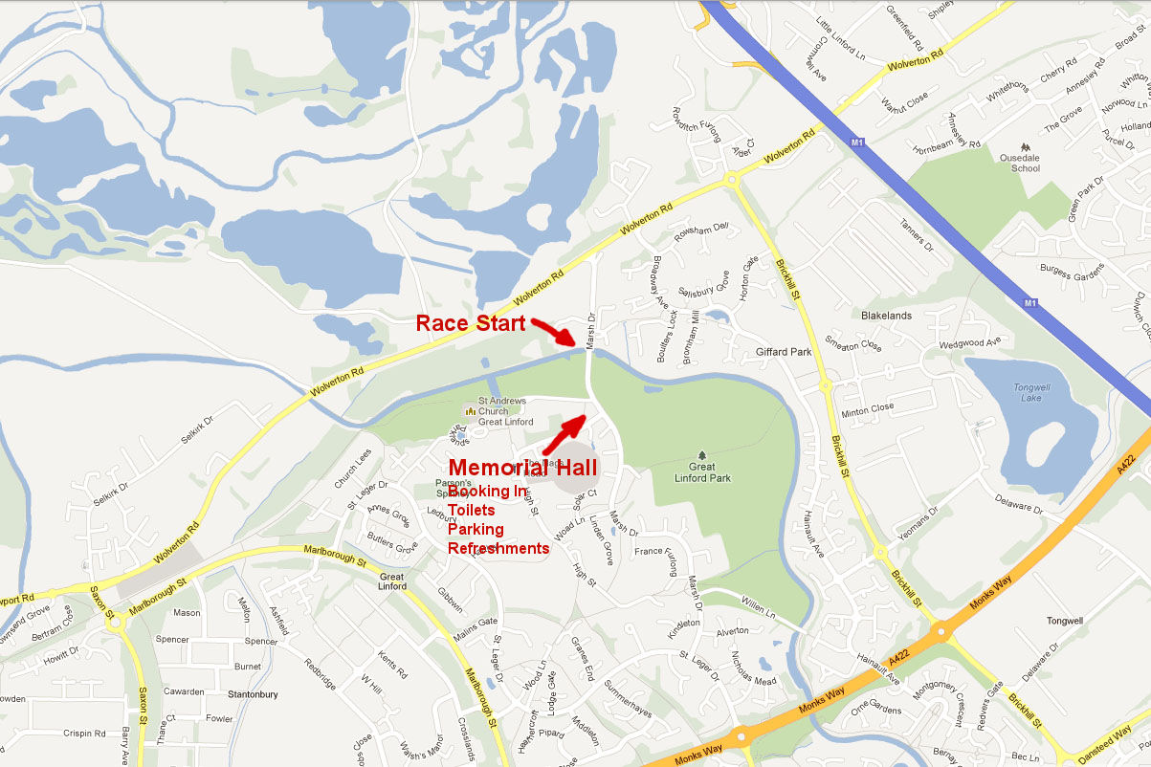
Map showing location of the start

Through Milton Keynes there are numerous bridges over the canal and footpaths and cycleways follow and cross the canal at many locations.

Please use the following links to find suitable locations for supporting your crew

http://www.ukwrs.co.uk/gecm/?p=110

http://www.waterexplorer.co.uk/gmaps/interactivecanalmap.aspx?GroupId=296

The first portage - is at Fenny Lock towards the Southern end of Milton Keynes

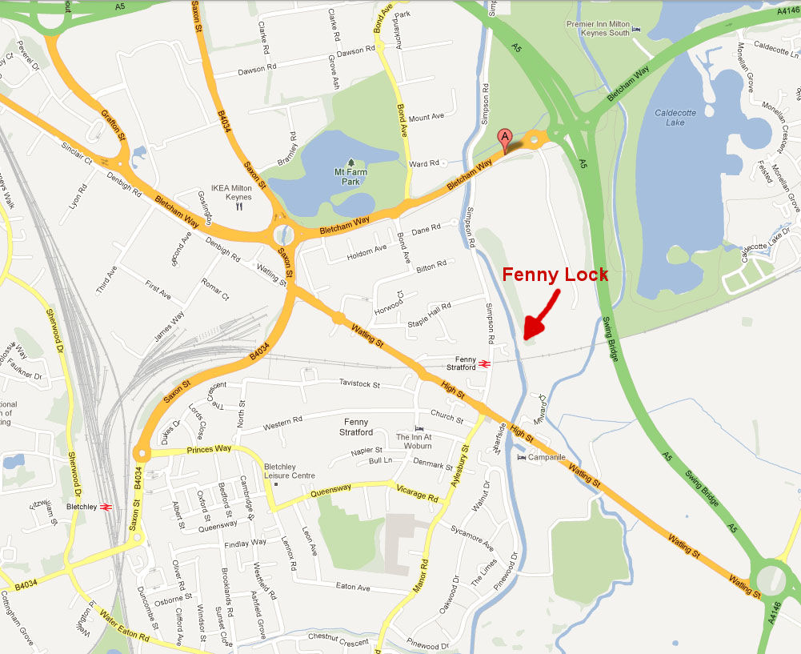

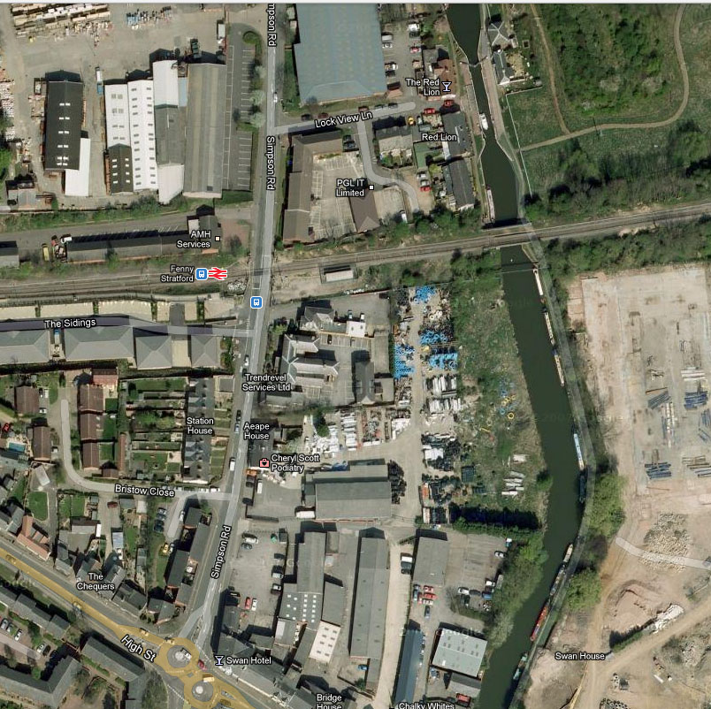
Access is easiest from
Fenny High Street
Along Simpson Road
Over the Level Crossing
Turn Right into Lock View Lane
The Lock will be in front of you
at the end of the road

The towpath is on the Eastern side of
the canal, the far side from the road

The Second Portage - will be at Stoke Hammond Lock (which is Lock 23)
Access to this lock is difficult the easiest way is to support crews is to stop at what we call the Stoke Hammond lay-by which is just past bridge 102 and cycle or run to the lock, which is just over a mile before the lock. After the lock the support crew could run or cycle just under half a mile to the next bridge 106 which is past Stoke Hammond.

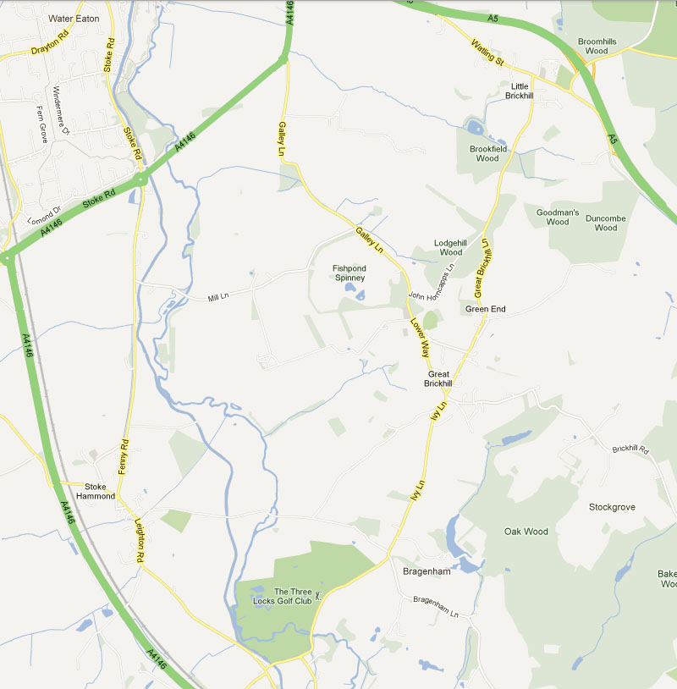
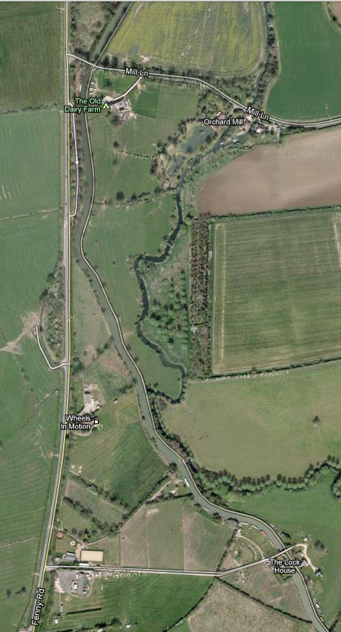
Stoke Hammond Lay-By
The towpath on the canal is on the far side from the lay-by (the East) so you need to cross the canal by the bridge at the Northern end of the lay-by.

At the lock the portage is on the same side as the towpath.

Stoke Hammond Lock
Stoke Hammond Lock

The third portage - is quite a long one as it is past all three of the Three Locks at Soulbury. The towpath is on the West of the canal before the locks and on the East after the locks but portaging is usually possible on either side of the locks and it is generally easier on the opposite side from the pub as there are fewer pedestrians and pub customers.

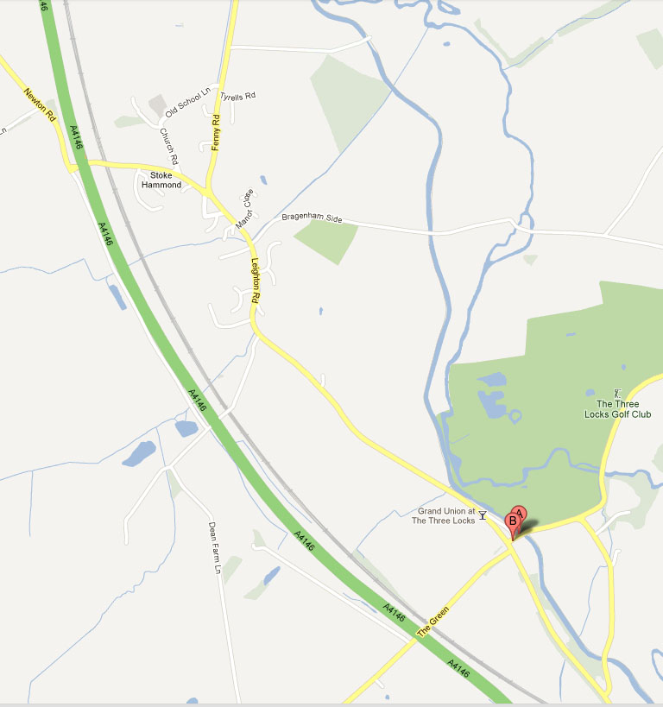
Street Map Around Three Locks

There is some parking in the old road that goes in front of the pub or alternatively you could park in the picnic area car park just after the road bridge past the final lock.

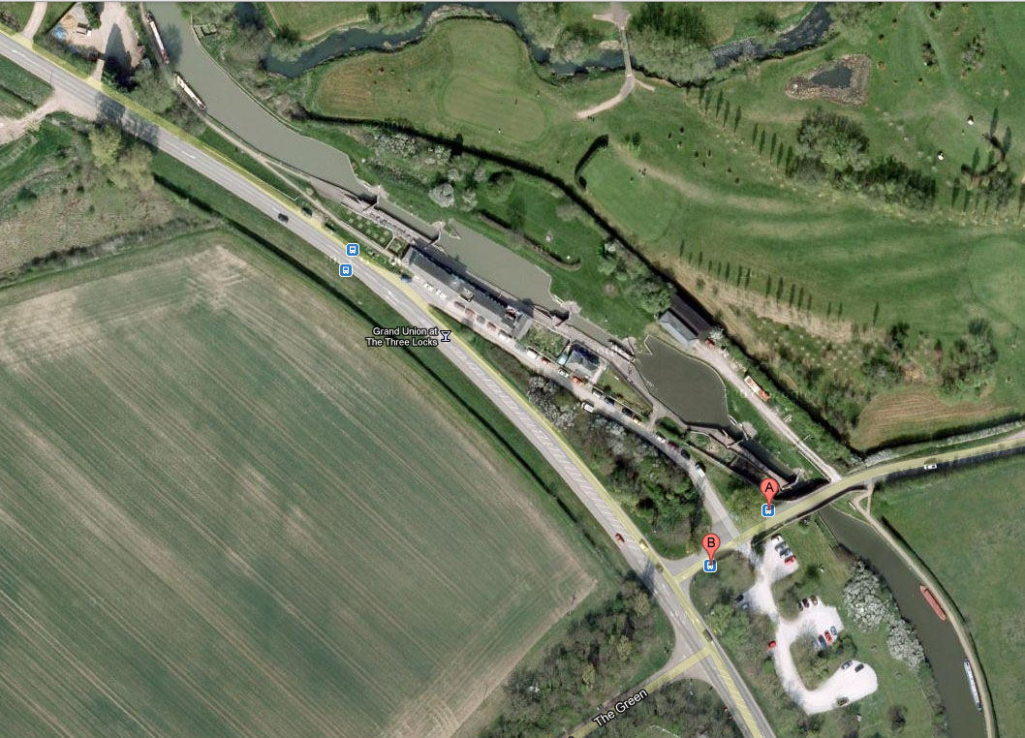
Aerial view of Soulbury Three Locks
The Fourth Portage - is at Leighton Lock (Lock 27) this is quite near to the finish and is difficult to get to on foot. There is NO access to the lock from The Martin’s Drive. You can walk up the towpath from the large Tesco’s car park near the town bridge or park in the housing estate behind Tesco’s and have a shorter walk from there. The towpath and portage is again on the East or to the right of the canal. After supporting your crew at the portage you may not be able to get to the finish in time to see the paddlers finish.

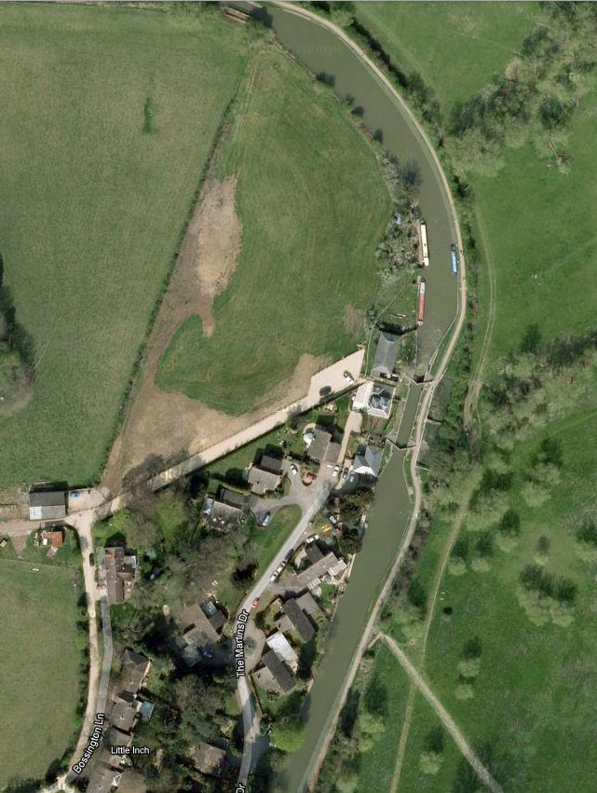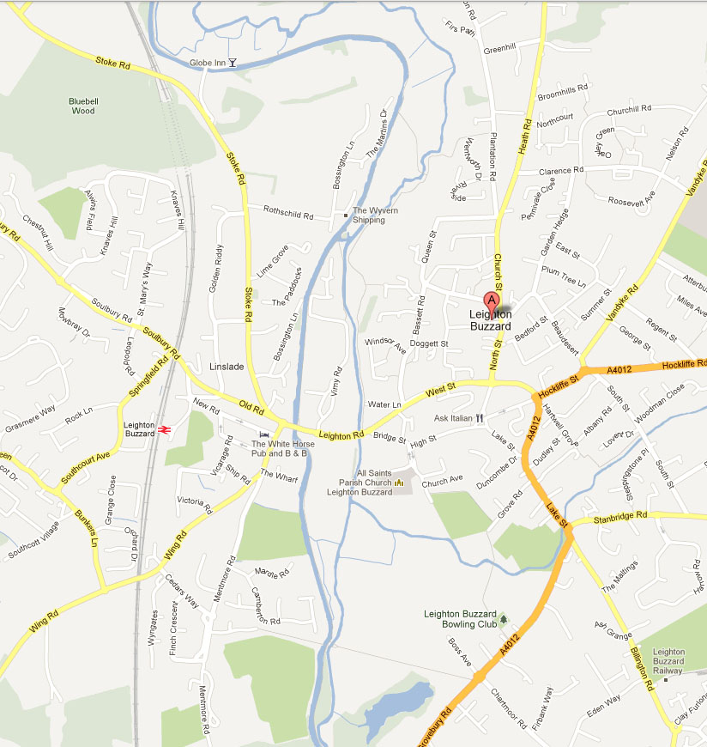
Canoe Club
Leighton Lock
Leighton Lock

The finish will be at the Black Bridge just before the Leighton Buzzard Canoe Club landing stage.

FINISH LOCATION Leighton Buzzard Canoe Club, at the rear of Cedars School / Tiddenfoot Leisure Centre, Mentmore Road, Leighton Buzzard, LU7 2AE
where Car Parking, Toilets & Refreshments will also be available.

If you have problems during the event and need to contact someone.

Catherine at Race Control will be available on 07830 254 562
Please only use this number if absolutely necessary.

If your crew retires please DO contact Race Control on the number above so that we can stop our marshals looking out for you.

