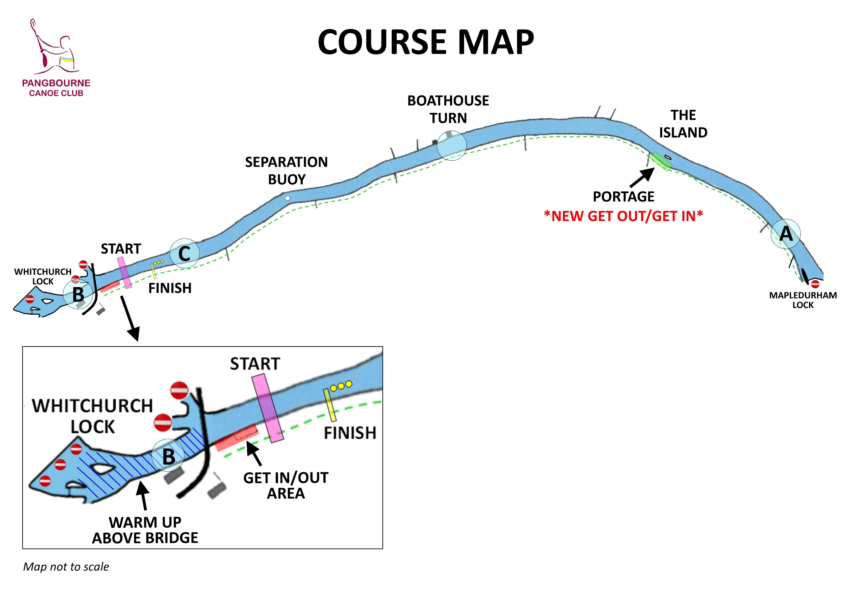
ALL TURNS ARE ANTICLOCKWISE.
STAY RIVER RIGHT UNTIL FINISHING.
ALL DISTANCES ARE APPROXIMATE
GS A/B/C & Mini K2 (3.5km)
START - BOATHOUSE TURN – river left after C - FINISH
Div 7,8,9,10 (6.5km)
START – Turn at A – river left after C - FINISH
Div 4,5,6 (13km)
START – PORTAGE – Turn at A –
Turn at B – PORTAGE – Turn at A – river left after C - FINISH
Div 1,2,3 (19.5km)
START – PORTAGE – Turn at A –
Turn at B – PORTAGE – Turn at A –
Turn at C – PORTAGE - Turn at A – river left after C - FINISH

