Course
- Start outside RCC heading downstream (towards London),
- Turn around left-hand pillar of Twickenham bridge counter-clockwise,
- Keeping to the right hand bank, paddle back upstream to the top of Glovers island,
- Turn counter-clockwise around Glovers Island and back to club pontoon = 1 lap.
- Full race = 3 laps (10kms), Class 4 race = 2 laps (6.67kms), Class 5 = 1 lap (3.33kms)
- River right at all times.

Participants to use two right arches of Richmond bridge on downstream course; will proceed upstream right of corporation island and will be hugging bank on upstream leg.

Rescue boats will be at top and bottom turns.

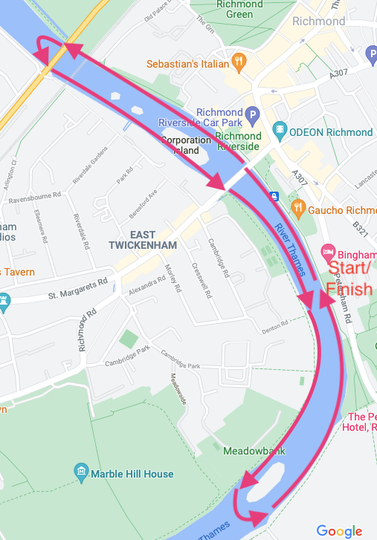

Expected Timings
09:15-09:30 Race debriefing
09:30-09:50 Getting on the water
10:00 Race start – class 1 k2 combined divisions 4 to 7
10:02 Race start – class 2 k2 combined divisions 8 to 11.
10:04 Race start – class 3 k2 combined divisions 12 to 15
10:06 Race start – class 4 k2 combined divisions 16 and above
10:08 Race start – class 5 k1 beginners

Instructions
All boats are to be on the river ahead of 09:50 and well before the first start. Ensure you put onto the river against the flow. Head upstream to Glovers
Start will be outside RCC facing downstream (towards London) – this is the only time you are allowed not to be on river right.
Start process – boats are to warm up around and above Glovers island, well upstream of the river bend. Waves will be called to gather at Glovers and will be escorted down by either a motor boat or kayak to the pre-start (to be displayed on a map but will be on the puppet show pontoon)
River right at all times
Give crews plenty of space on the turns – bridge pillars are a hazard
Flow (briefing will depend on conditions especially taking into account turns and moored boats)
Tide – High tide at midday, so the tide will start coming in during the race. This will offset the natural river flow to make for hopefully still water (depending on the rainfall and river levels).
Any additional obstacles identified on the course on the day
Participants are required to use the right two arches of bridges when approaching them (will be detailed on the race map). Will place a marshal on the land (Richmond bridge and river bend above club) to ensure participants are right of the buoys
At the end, participants are required to paddle downstream of the finish and turn clockwise around moored boats and to proceed between moored boats and the bank to return to RCC – out of way of race and river traffic
Divisions 7-9 paddlers must wear buoyancy aids, regardless of the class entered
All juniors must wear buoyancy aids

All paddlers who fail to finish must report to a Marshal and inform them of their boat number and the fact that they have retired.

Pre-race instructions

Buoyancy Aids
ALL paddlers should bring buoyancy aids. Division 7-9 paddlers must wear buoyancy aids, regardless of the class entered. Buoyancy aids may be also declared compulsory on the day for some or ALL other classes depending on conditions. This includes Division 1 paddlers.

All juniors must wear buoyancy aids.

Team leaders should decide if other paddlers should wear them according to prevailing conditions.

The race organisers may request that all or some paddlers in addition to the above may need to wear buoyancy aids, the race organisers’ decision is final.

Kit Requirements
In the event of cold weather, paddlers considered by the race organisers to be too lightly dressed will not be permitted to take part. The safety marshal’s decision in this matter will be final.

Boat Buoyancy
All boats must carry sufficient buoyancy secured in both ends to support their own weight plus that of crew members in the water, e.g. inflated airbags or fixed buoyancy blocks. Boats may be inspected before the start and any boats not meeting the requirements will not be allowed to race.

Retirements
All paddlers who fail to finish must report to a Marshal and inform them of their boat number and the fact that they have retired.

Other Notes
Should circumstances require the abandonment of the race whilst in progress, the following procedure will apply:

Crews on hearing continuous short blasts on air horns and/or being instructed by marshals will immediately STOP. They will wait to be instructed on how and where to proceed by a marshal. Crews must be aware that other crews may not have heard or seen the warnings, and must pass on instructions received to any such crew who they see still racing.

Depending on crews’ locations, whether or not the Race has started and the number of crews still being marshalled, they may be asked to either paddle to a specified get-out point, or turn towards one of the banks and await further instructions.

Competitors should be aware that the lower Thames can be busy with pleasure cruisers, rowers and other craft. Competitors must be mindful of these and other hazards. Competitors must follow any direction given by Port of London Authority Officers, Environment Agency Officials or Race Marshals.

Competitors must provide support to any other paddler in distress and should attempt to raise the attention of one of the safety boats or Marshals along the course.

The River Thames can experience sudden increases in pollution, especially after heavy rainfall. Any paddler who feels ill after the race should draw this to the attention of their medical practitioner.

Canoeing and Kayaking in all its forms is an ‘Assumed Risk – Water Contact’ sport. The organisers have done their very best to provide a safe racing environment, but competitors are reminded of their duty of care to themselves and all other competitors. Safety is a shared responsibility.

