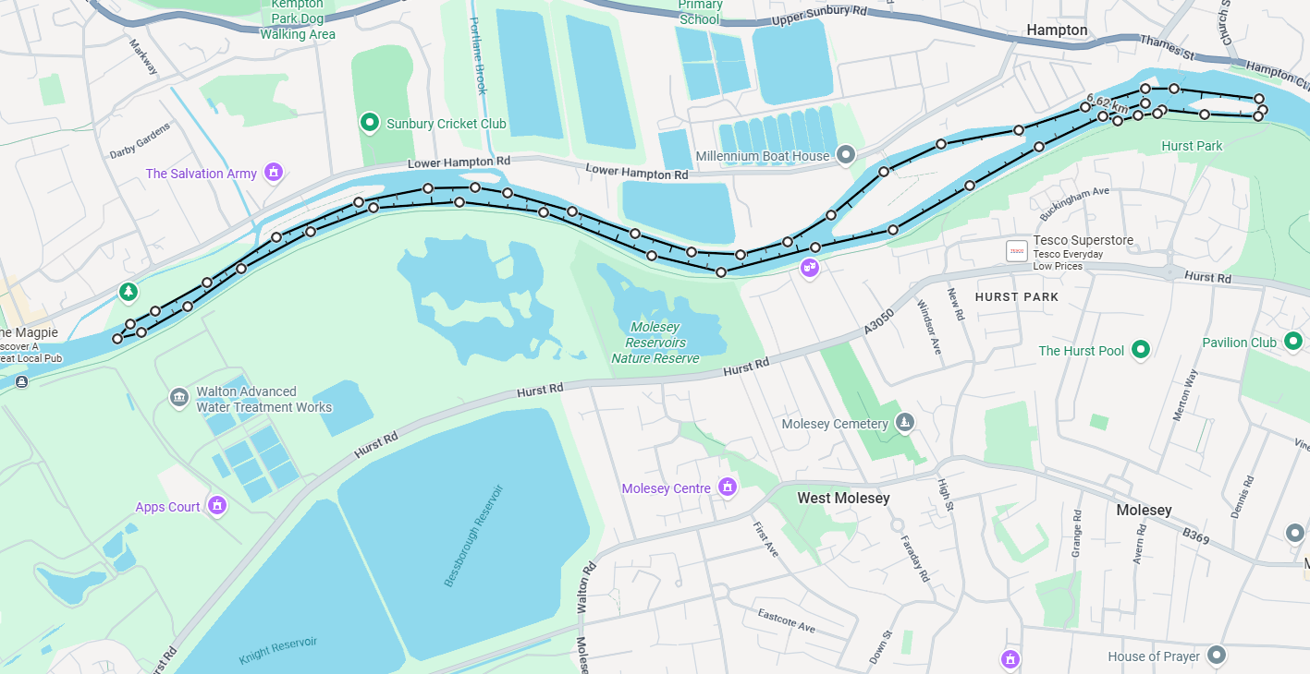
Course Description
Course:
- Start facing upstream between Hurst park and Hampton Sailing Club.
- Keeping river right, paddle past Platt’s Eyot, up to a turning bouy before Sunbury lock c. 3 kms upstream from the start.
- Paddle back downstream, river right towards the start to the portage at Hurst Park.
- After the portage continue downstream and turn anti-clockwise around Garricks Ait, back up to the start
- This is 1 full lap.
- Div 1-3 : 3 laps (2 portages), 4-6: 2 laps (1 portage) , 7-9: 1 lap (no portages)
- NB Do not portage on the final lap. Finish paddling downstream across the finish line between Hurst Park and Hampton Sailing Club

