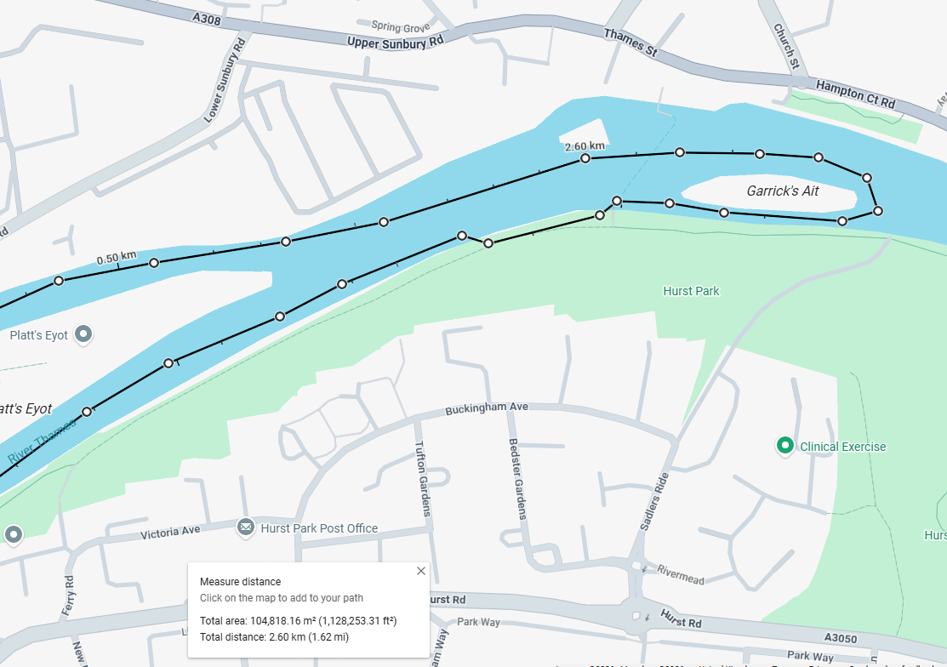
Access to Car Park via Ferry Road
Pre-start/ warm up area
Emergency access only via Sadlers Ride
- Footpath to remain clear at all time for general public
- Portage will have a taped off area of c. 100m near the river (not on the Tow path)
- Access to competitors/ spectators via Ferry Road. Marshal’s positioned to direct vehicles
- Race area taped off for race officials/ first aid only
- Portable toilets will be available for competitors and spectators

Paddlers/ spectators zone
Toilets
Portage
Start/ finish line
Race HQ/ fist aid
Car Park

